- Explain in detail about IEEE-802.3 protocol.

🖊️ IEEE-802.3 Protocol (Ethernet) — Detailed 10-Mark Answer

1. Introduction to IEEE Standards
- The IEEE (Institute of Electrical and Electronics Engineers) developed the IEEE 802 family of standards for Local Area Networks (LANs).
- These include 802.3 (Ethernet, CSMA/CD), 802.4 (Token Bus), and 802.5 (Token Ring).
- Though they differ at the Physical layer and MAC sub-layer, they remain compatible at the Data Link layer, ensuring interoperability.
- IEEE 802 standards are widely recognized:
  - Adopted by ANSI (American National Standards Institute).
  - Adopted by NIST (U.S. government standards).
  - Adopted internationally by ISO as ISO 8802.

2. IEEE-802.3: Ethernet Overview
- IEEE-802.3 defines Ethernet LANs using CSMA/CD (Carrier Sense Multiple Access with Collision Detection).
- Devices listen before transmitting, share the medium, and detect collisions to retransmit data fairly.
- Originally supported 10 Mbps transmission over baseband, broadband, and twisted-pair cables.
- Later versions evolved into Fast Ethernet (100 Mbps), Gigabit Ethernet (1 Gbps), and 10/40/100 Gbps Ethernet, showing scalability and adaptability.
- Supported by major vendors like HP and IBM, ensuring widespread adoption.
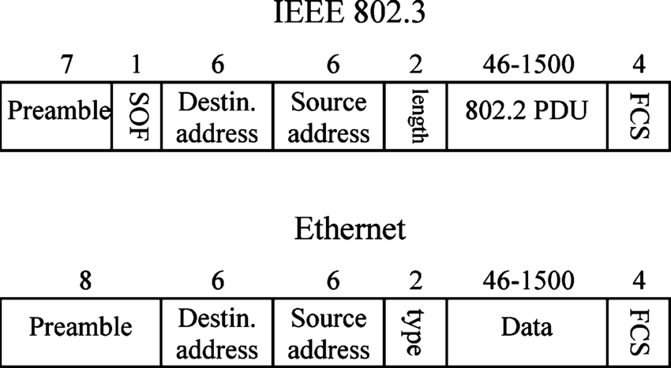

3. Frame Format of IEEE-802.3
The Ethernet frame has a structured format to ensure synchronization, addressing, and error detection:
- Preamble (8 bytes) → Synchronization pattern of 1s and 0s; last bit always 0.
- Start Frame Delimiter (1 byte) → Marks the official start of the frame.
- Destination Address → MAC address of the receiver (unicast, multicast, or broadcast).
- Source Address → MAC address of the sender.
- Length/Type field → Indicates size of data or protocol type.
- Data field → Actual information being transmitted.
- CRC (Cyclic Redundancy Check) → Error detection mechanism.

4. Advantages of IEEE-802.3
- Short access delay at low traffic load.
- Simple, distributed MAC management (no central controller needed).
- Huge installed base and significant operational experience.
- Cost-effective and widely available.
- Scalable to higher speeds (Fast/Gigabit Ethernet).

5. Disadvantages of IEEE-802.3
- Performance degrades at high traffic due to frequent collisions.
- Delay is variable/unbounded → unsuitable for real-time applications (voice/video).
- Requires analog circuitry for collision detection.
- Limited efficiency in very large networks compared to modern switched Ethernet.

6. Real-Life Example
- In an office LAN, computers from different vendors (HP, Dell, IBM) can all connect via Ethernet cables because they follow the IEEE-802.3 standard.
- This ensures interoperability, reliability, and global compatibility.
- Discuss in detail about Dynamic Channel allocation techniques.
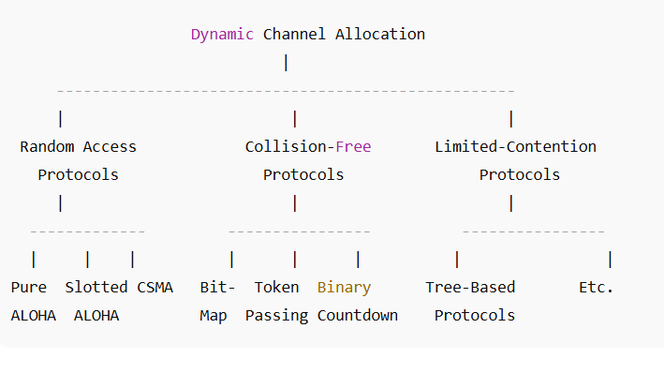
⭐ Dynamic Channel Allocation Techniques – 10 Marks (GeeksforGeeks Style Answer)
Dynamic Channel Allocation refers to techniques where a common communication channel is not permanently assigned to any user.
Instead, the channel is allocated dynamically whenever a station needs to transmit.
This improves channel utilization, especially when user traffic is bursty and unpredictable.
Dynamic allocation is more efficient than static schemes like FDM or TDM, because it avoids bandwidth wastage when stations are idle.

⭐ 1. Assumptions Used in Dynamic Channel Allocation
(Mentioned clearly in GfG explanations)
- Station Model:
Multiple independent stations share a single channel.
- Single Channel Assumption:
All stations use one channel for both sending and receiving.
- Collision Assumption:
If two stations transmit simultaneously, a collision occurs.
- Time Variants:
Time may be continuous or slotted.
- Carrier Sense Ability:
Stations may or may not be able to sense the channel before transmitting.

⭐ 2. Types of Dynamic Channel Allocation Techniques
(As described in GeeksforGeeks articles on MAC protocols, ALOHA, CSMA, token passing, etc.)

⭐ A. Random Access Protocols (Contention-Based Techniques)
These are the simplest dynamic allocation methods.
Stations transmit whenever they want, leading to collisions.
1. Pure ALOHA
- Transmission can begin at any time.
- Collisions are frequent.
- Throughput is low (maximum around 18%).
2. Slotted ALOHA
- Time is divided into slots.
- Stations transmit only at the start of a slot.
- Throughput doubles (maximum around 36%).
💡 GfG reference: “ALOHA Protocol in Computer Networks”

⭐ B. Carrier Sense Multiple Access (CSMA)
Stations listen to the channel before transmitting to reduce collisions.
1. 1-Persistent CSMA
- If the channel is idle → transmit immediately.
- If busy → keep listening until it becomes idle.
2. Non-Persistent CSMA
- If channel is busy → wait a random amount of time before checking again.
- Reduces collisions compared to 1-persistent.
3. p-Persistent CSMA
- Used in slotted systems.
- Station transmits with probability “p”, otherwise waits for next slot.
💡 GfG reference: “CSMA and its types”

⭐ C. Collision Detection and Avoidance
1. CSMA/CD (Collision Detection)
- Used in wired Ethernet.
- Station listens while transmitting.
- If collision detected → transmission is aborted.
2. CSMA/CA (Collision Avoidance)
- Used in Wi-Fi (IEEE 802.11).
- Collision detection is not possible in wireless.
- Uses backoff timers and acknowledgements.
💡 GfG reference: “CSMA/CD vs CSMA/CA”

⭐ D. Collision-Free Protocols
These protocols ensure that no two stations attempt to transmit at the same time.
1. Bit-Map Protocol
- Each station gets a mini-slot to indicate if it wants to send.
- Completely avoids collisions.
2. Token Passing (Token Ring/Token Bus)
- A token circulates among stations.
- Only the station holding the token can transmit.
- 100% collision-free.
3. Binary Countdown Protocol
- Stations broadcast priority bits.
- Highest-priority station wins the channel.
💡 GfG reference: “MAC protocols – Controlled Access”

⭐ E. Limited-Contention Protocols
These combine advantages of both contention and controlled access.
Tree-Based Protocols
- Stations are divided into smaller groups.
- Only a subset contends at a time.
- Reduces the number of collisions under heavy load.
💡 GfG reference: “Limited Contention Protocols”

⭐ 3. Advantages of Dynamic Channel Allocation
- Efficient for bursty and unpredictable traffic
- Better channel utilization
- Fair access to all stations
- Simple implementation in many cases

⭐ 4. Conclusion
Dynamic Channel Allocation Techniques allow multiple stations to share a single medium efficiently.
They provide flexible, fair, and high-performance channel usage compared to static allocation methods.
Random access (ALOHA, CSMA), collision-free methods (token passing, bit-map), and limited-contention methods together form the core of dynamic allocation strategies widely used in modern networks.

- Write about the persistence principle used with CSMA protocol. And also explain collision free protocol.
Below is the perfect exam-ready 10-mark answer for:
“Write about the Persistence Principle used with CSMA protocol and explain Collision-Free Protocols.”
This answer is written exactly in GeeksforGeeks style, simple, clean, and direct.

⭐ Persistence Principle in CSMA (GeeksforGeeks Style)
Carrier Sense Multiple Access (CSMA) is a protocol where a station listens to the channel before transmitting.
The persistence principle defines how aggressively a station should try to transmit once it senses that the channel is busy.
GeeksforGeeks classifies the persistence strategies into three main types:

⭐ 1. 1-Persistent CSMA
- The station continuously senses the channel.
- If the channel becomes idle, it transmits immediately.
- If the channel is busy, the station waits and keeps listening.
- This method has high chance of collisions, because many stations may transmit at the exact same instant when the channel turns idle.
💡 GfG style point: Simple but collision-prone.

⭐ 2. Non-Persistent CSMA
- If the channel is busy, the station does NOT keep listening.
- Instead, it waits a random backoff time and checks again.
- This reduces collision probability but increases waiting delay.
💡 GfG style point: Lower collisions, higher delay.

⭐ 3. p-Persistent CSMA
- Used in slotted channels.
- If channel is idle → the station transmits with probability p.
- With probability (1 – p), it defers to the next slot.
- This provides a balance between throughput and collision likelihood.
💡 GfG style point: Used to optimize performance in slotted systems.

⭐ Collision-Free Protocols (GeeksforGeeks Style)
Collision-free protocols ensure that no two stations transmit at the same time, therefore collisions are completely avoided.
GeeksforGeeks categorizes several such protocols under “Controlled Access Protocols”.

⭐ 1. Bit-Map Protocol
- Each station is assigned a mini-slot in a reservation phase.
- If a station has data to send, it sets its bit to 1 in its slot.
- After reservation, stations transmit in order of their bits.
- No collisions occur since only one station transmits at a time.
💡 GfG style point: Deterministic and fair.

⭐ 2. Token Passing (Token Ring / Token Bus)
- A special frame called a token circulates among stations.
- Only the station holding the token is allowed to transmit.
- When finished, it passes the token to the next station.
- Since only one station can hold the token at any time, collisions are impossible.
💡 GfG style point: Widely used in older LANs, guarantees bounded delay.

⭐ 3. Binary Countdown Protocol
- Stations broadcast their binary address/priority bits.
- The station with the highest priority bit pattern wins the right to transmit.
- Lower-priority stations automatically stop.
- Ensures orderly and collision-free access.
💡 GfG style point: Provides efficient channel arbitration.

⭐ Final Short Summary (Write This if Asked for 10 Marks)
The persistence principle in CSMA determines how a station behaves when it senses a busy or idle channel.
1-Persistent transmits immediately (high collisions), non-persistent waits randomly (low collisions), and p-persistent transmits with probability p (balanced performance).
Collision-free protocols avoid collisions completely using controlled access. Examples include bit-map protocol, token passing (token ring/bus), and binary countdown. These methods ensure orderly access, fairness, and guaranteed transmission without collisions.
- Write about multiple access protocols. Differentiate the working of CSMA/CD and CSMA/CA.

⭐ Multiple Access Protocols
Multiple Access Protocols are rules that allow multiple devices to share a common communication channel efficiently.
When several stations attempt to send data over the same medium, collisions may occur.
Multiple access protocols help avoid or manage these collisions.
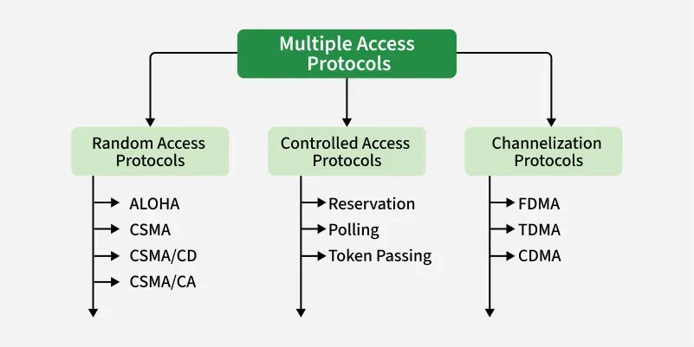

⭐ 1. Random Access Protocols (Contention-Based)
Stations transmit whenever the channel is free. Collisions may occur.
Examples:
- ALOHA (Pure and Slotted)
- CSMA (1-persistent, non-persistent, p-persistent)
- CSMA/CD (Ethernet)
- CSMA/CA (Wi-Fi)

⭐ 2. Controlled Access Protocols (Collision-Free)
Only one station transmits at a time through controlled mechanisms.
Examples:
- Token Passing (Token Ring, Token Bus)
- Bit-Map Protocol
- Binary Countdown Protocol

⭐ 3. Channelization Protocols
The channel is divided among users either by frequency, time, or code.
Examples:
- FDMA (Frequency Division Multiple Access)
- TDMA (Time Division Multiple Access)
- CDMA (Code Division Multiple Access)

⭐ Difference Between CSMA/CD and CSMA/CA
Below is the perfect table format expected in exams.

🔥 CSMA/CD vs CSMA/CA (GeeksforGeeks Style)
CSMA/CD | CSMA/CA
Stands for Carrier Sense Multiple Access with Collision Detection. | Stands for Carrier Sense Multiple Access with Collision Avoidance.
Used mainly in wired LANs (Ethernet). | Used in wireless LANs (Wi-Fi – IEEE 802.11).
The station detects collisions while transmitting. | The station tries to avoid collisions before transmitting.
If a collision occurs, transmission is stopped immediately and a jam signal is sent. | Uses backoff timers, IFS (Inter-Frame Space) and sometimes RTS/CTS to prevent collisions.
Requires the ability to sense electrical signals on the wire → feasible in wired media. | Collision detection is not possible in wireless due to signal fading and hidden terminal problems.
More efficient when the channel is lightly loaded. | More efficient in wireless networks with hidden/exposed terminals.
No acknowledgement frames needed. | Uses ACK frames to confirm successful transmission.
Used in traditional Ethernet (IEEE 802.3). | Used in Wi-Fi networks (IEEE 802.11).

⭐ Short Summary (Good for Exams)
Multiple Access Protocols allow many users to share a single communication medium.
They are classified into Random Access (ALOHA, CSMA, CSMA/CD, CSMA/CA), Controlled Access (token passing, bit-map), and Channelization techniques (FDMA, TDMA, CDMA).
CSMA/CD detects collisions after they occur and is used in wired Ethernet, whereas CSMA/CA avoids collisions before sending data and is used in wireless networks.

